Frequently asked Questions at Coleman Family Center
Q: How do I enroll my Child(ren)?
A: Contact our team at ececoleman@greatermidland.org with general questions or to inquire about availability or reach us by phone at (989) 465-2079

Q: What are the childcare rates?
A: Our daily rates are as follows (DHHS assistance is accepted for qualifying families)
Full Day (over 5 hours) Infant/Toddler = $39 Half Day (5 hours or less) = $24
Full Day Childcare age 3-5 = $36 Half Day = $24
3’s Preschool Only Full Day = $36 Half Day = $20
3’s Preschool Only Scholarship Full Day = $16 Half Day = N/A
Before & After School Program (Kindergarten-6th grade) = $9 per session
Full Day School Age = $29 Half Day = $24

Q: What is the staff to child ratios?
A: All Greater Midland Early Care & Education classrooms adhere to State of Michigan licensing rule
400.8182 which detail the Ratio and group size requirements for each group.
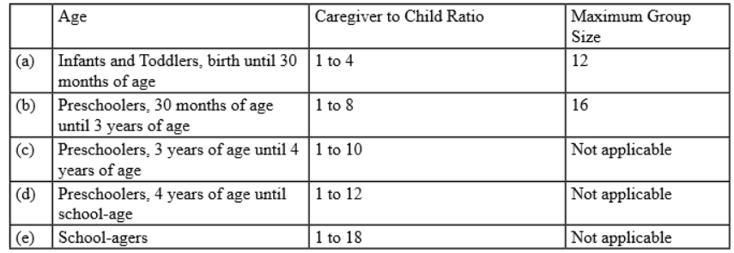

Q: Does Greater Midland require a criminal history check for employees?
A: Yes, Greater Midland follows the State of Michigan licensing requirements for all licensed childcare centers.
Greater Midland requires Live scan Fingerprints – A fingerprint clearance includes a nationwide FBI
criminal record check and a Michigan State Police criminal history check. A fingerprint clearance is required for all registrants, licensees or licensee designees and child care center program directors.
Greater Midland also runs an Internet Criminal History Access Tool (ICHAT) – An ICHAT clearance checks public records contained in the Michigan Criminal History Record maintained by the Michigan State Police. An ICHAT clearance is required on all employees of child care homes and centers prior to an offer of employment.

Q: Is there a minimum numbers of days per month requirement?
A: Families are responsible for maintaining a minimum of 16 days of care per month. Families scheduling
fewer days will be charged for 16 days.
*Children ages 6 weeks through 2 years are required to maintain 16 Calendar Days per month
*Children ages 3+ are required to maintain 16 Calendar Days per month
Families will be charged for the number of days they register for on their monthly calendar. If your child
does not attend care on your scheduled days, you are responsible for payment on those days. If Greater
Midland Coleman Family Center closes, families will NOT be charged for the days care is unavailable.

Q: Is there a sibling/second child rate?
A: Greater Midland Coleman Family Center does not offer a sibling/second child discount as our overall daily rate is considerably lower then market rate in effort to allow families of all income levels to participate in high quality early care & education.

