Parent/Guardian Handbook

Greater Midland Community Center
Early Care & Education

Updated 5/29/2023

Mission Statement -------------------------------------------------------------------------------------------------
.
Philosophy ------------------------------------------------------------------------------------------------------------
At Greater Midland we know all children can be successful. It is our privilege and responsibility to provide a high-quality Early Care & Education experience for all learners. Every kid is “our kid.”

Goals ------------------------------------------------------------------------------------------------------------------
Children & families are
- Create an environment that promotes growth through play and exploration
- Children and families have a sense of belonging
- Our team is invested in the future success of every child
- Every child has developmentally appropriate learning opportunities
- Encourage independence
- Children enter kindergarten developmentally ready to learn and succeed
- Learning is not limited to the classroom

Admissions Policy --------------------------------------------------------------------------------------------------

Children must be between the ages of 6 weeks and 6 years. There is a $60 waitlist fee to hold a slot for your child. Enrollment is based on availability. A $35 annual non-refundable processing fee per family must be paid in full before enrollment paperwork will be processed. All required enrollment paperwork must be completed and submitted a minimum of 2 weeks before care begins. The following paperwork is required:
- Child Information Card
- Immunization Record
- Health Appraisal (completed by physician)
- DHHS Verification form/Scholarship letter (if applicable)
- Code of Conduct
- Parent Notification of Licensing Notebook
- All Permission Slips
- Child “Get to Know You” form
- Consent to Share (if applicable)
- Court paperwork pertaining to custody arrangements (if applicable)

Hours of Operation -------------------------------------------------------------------------------------------------

Early Care & Education is in session Monday through Friday from 7:00 a.m. – 6:00 p.m.

We do expect children who are in our preschool program (2.5 years and up) to arrive no later than 9:00am.

Hours of operation are affected by the following holidays:

New Year’s Eve & New Year’s Day CLOSED
Christmas Eve & Christmas Day CLOSED
Easter CLOSED (observed on Monday)
Good Friday (pending enrollment)
Memorial Day CLOSED
4th of July CLOSED
Labor Day CLOSED
Thanksgiving CLOSED
Black Friday (pending enrollment)

*Regarding days pending enrollment, families will be notified a minimum of 2 weeks in advance
*If a holiday falls on a weekend, we will observe that day on either the Friday or Monday.

Communication---------------------------------------------------------------------------------------------------------

Communication is essential as we work together to meet the needs of your child(ren.) Several methods of communication are available. Daily Sheets (brief summary for all infant and toddler families of their child’s schedule- outlining meals/snacks, diaper changes/restroom use, sleep schedule, needs and milestones.)
- Social Media Platforms (see Lead Teacher for classroom details)
- COR Advantage
- Newsletters
- Conferences
- Family Events/Family Education opportunities
- Email/Phone

(989) 832-7937 then dial classroom or office extension:

Childcare Office | 2237
Billing Specialist | 2214
Program Director | 2312
Multi-Site Director | 2277
Tiny Learners 1 | 2233
Tiny Learners 2 | 2236
Voyagers 1 | 2234
Voyagers 2 | 2235
Explorers 1 & 2 | 2239
Young Preschool 1 | 2238
Early Preschool | 2311
PreK + | 2240

For general inquiries that are not time sensitive our office can be reached at childcare@greatermidland.org

Family Involvement ---------------------------------------------------------------------------------------------------

As your child’s first and most important teacher YOU are an integral part of our program. We strive to develop a strong partnership between home and school to benefit the growth and development of your child (ren.) Our team will keep you updated with all pertinent program and child related information. Please check frequently:
- Bulletin boards
- Email
- Child Cubbies
- Sign In/Out Clipboard
- Newsletters
- Social Media Pages
(Specific classroom information available from Lead Teacher)

We ask that all contact information is kept up to date. If a change is required, please see our administrative office team.
Teacher conferences are held twice per year. Additional meetings may occur at the request of either the teacher or parent/guardian.
There are many opportunities to participate in your child’s Early Care & Education experience including but not limited to: special classroom events, volunteering, family events/activities, field trips.

Scheduling & Payments -----------------------------------------------------------------------------------------------

Monthly registration is required for care. Registration due no later than the 24th of each month using our online system. For example: (October calendars are due September 24th).

Early registration is always appreciated!
- Greater Midland charges a $20 Late Registration Fee per child for registrations received after the due date.
- Greater Midland charges a no registration fee of $35
- Without registration, care CANNOT be guaranteed.
We understand that circumstances may arise that require families to change their schedule after their registrations are submitted. Changes must be approved by your child’s Lead Teacher. We CANNOT guarantee care will be available when changes are made to a calendar that has already been submitted.
When adding a day of care families are responsible for an additional $5 Add Fee on top of the daily rate.

Families are responsible for maintaining a minimum of 19 days of care per month. * Families scheduling fewer days will be charged for 19 days. Greater Midland only offers full day care for all ages.

Payments due on the 24th at the time of registration. Method of payment available: Debit/Credit Card. DHHS families will be charged 20% of their total to be paid at the time of registration.

- Households carrying past due balances could experience suspension of or discontinuation of care.
- Households that qualify for childcare scholarship through Greater Midland Community Center must keep their account current. If the account is not in good standing, scholarships may be discontinued.
- Sliding- fee forms available online and need to be turned into the community Center Welcome Desk.

- Please see our Billing Specialist for payment arrangement details.

Drop Off & Pick Up -----------------------------------------------------------------------------------------------------

- No child will be released to a person NOT noted on the Child Information Card
- No child will be released to a person under the age of 18.
- Photo ID can be requested at any time for any reason. We will NOT release a child to anyone who fails to provide a photo ID upon request.
- Any changes to Authorized Pick-Up list located on the Child Information Card MUST be made in person in the administrative office.
- Changes to the Authorized Pick-Up list cannot be made over the phone, through email, text. All changes MUST be made in person.
- Authorities will be contacted in the event that any person attempting to pick up a child appears under the influence.
- We are obligated to release children to legal guardians listed on child information card unless appropriate documentation by the court is on file.
- Parents/Guardians are expected to pick up/drop off their child(ren) within 15 minutes of their scheduled time. The 15-minute grace period does NOT apply beyond normal operating hours.

- For example, children scheduled to arrive at 6:30 a.m. cannot arrive at 6:15 a.m. as this does not fall into normal operating hours. All children MUST be picked up by 6:00 P.M.
- Late pick up fee: All children should be picked up on time. A late fee of $1 per minute per child will be added after the center closes. We understand that emergencies can occur, if this should happen a courtesy call is appreciated. After 15 minutes past closing the emergency contacts in your file will be called. After one hour, Child Protective Services will be notified.

Personal Belongings ----------------------------------------------------------------------------------------------------

Greater Midland is NOT responsible for any lost, broken, or stolen items. We ask that all toys, money, electronics etc. Be kept at home. Items brought from home will be kept in the child’s cubby or administrative office and can be taken home at the end of the day. One comfort item will be allowed during rest time. Examples of recommended items might be a blanket, stuffed animal, or picture from home. Please see your child’s Lead Teacher with any questions regarding comfort items or special days/activities in which children can bring items from home.

Nutrition -------------------------------------------------------------------------------------------------------------------

The daily meal program includes Breakfast, A.M Snack, and Lunch & Afternoon Snack
Infant: Families are responsible for providing either formula or breastmilk and meals once children begin eating cereal and/or “baby food.” Formula must come prepared (in bottles with nipples ready to serve.) Breastmilk can arrive in bottles ready to serve, in freezer safe bottles or in freezer safe bags. All food MUST be dated and labeled with child’s first and last name. Greater Midland provides some snacks (such as fresh fruit, apple sauce, dry cereal, “crunchies” yogurt.) Per the State of Michigan all infants will eat on demand.
Toddler-Preschool: Greater Midland provides Breakfast and Afternoon Snack (Families are responsible for providing lunch- Greater Midland will provide milk for lunch every day. Greater Midland will ensure milk or 100% juice is available at breakfast and snack each day. A current menu will be posted in the classroom. Copies available upon request.

Meal requirements for the Food Program are available upon request. In accordance with federal law, U.S. Department of Agriculture (USDA) policy and the values of Greater Midland; discrimination based on race, color, national origin, sex, age or ability is strictly prohibited.

Children with special dietary needs, such as those with allergies will work with the Lead Teacher to accommodate such needs. All food allergies must be documented in the child’s file in the administrative office. If the child’s needs exceed our ability to provide meals/snacks safely we may suggest that families provide their own food items from time to time.

*If you are experiencing difficulty or food insecurity, please contact your Program Director as assistance may be available.
*Classrooms may contain peanut-free tables to accommodate needs ALSO entire classrooms may become peanut-free/egg-free at any time.

Rest Time ------------------------------------------------------------------------------------------------------------------

Rest time is available to all children. Infants sleep on demand. Toddlers through preschool will have a scheduled rest time up to 2 hours. (Times may differ slightly on field trip days or for special events.) Rest time is a licensing requirement per State of Michigan, for any child in care for more than 5 continuous hours.

Children cannot and will not be forced to sleep. However, it is expected that children rest during this time to allow others to sleep. “Non-sleepers” will have the opportunity after approximately 20-30 minutes of quiet resting to do quiet activities on their rest mat/cot that will not disrupt sleeping children. Books, puzzles, coloring pages, small games etc. are some examples of activities children may have access to during rest time.

Rest mats/cots that are in good condition and sanitized in accordance with licensing requirements will be provided to every child. It is the responsibility of the family to provide blankets, mat/cot covers (optional) for their child (ren.) We ask that families bring no more than 1 rest time comfort item.
Per State of Michigan and center policies rest items must be laundered weekly, it is the responsibility of the family to launder items and return them to the center for use each week.
*If you are experiencing difficulty securing rest time items or laundering rest time items, please contact your Program Director as assistance is available.

Outside Learning ---------------------------------------------------------------------------------------------------------

Children go outside daily. Please dress your child appropriately (Weather permitting). Time spent outside will equate to approximately 10 minutes of every hour spent in care. (Example: 6 hours in care= 60 minutes outside). Our staff use the chart below to inform their decision on how long the children will be outside. Although, other factors may also influence our decision to take the children outside.
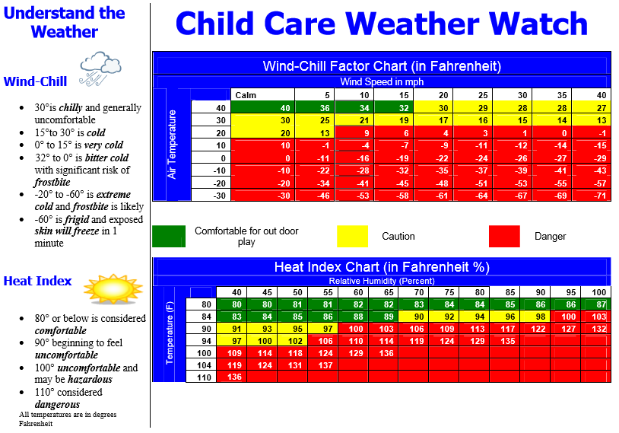
All children present for care will be considered well enough to participate in outdoor time. We are not staffed to say inside with children who are unprepared for time outdoors.
Sunscreen will be provided and will be applied as needed. If children require a specific brand of sunscreen due to unique needs such as allergies or sensitivity it will be the responsibility of the family to provide their own sunscreen and to inform staff of the allergy/sensitivity/preference.
*If you are experiencing difficulty acquiring outdoor apparel for your child (ren) please contact your Program Director or the Director as assistance is available.

Field Trips -----------------------------------------------------------------------------------------------------------------

Field trips are an excellent strategy to enhance classroom learning. A field trip is defined as anytime a child leaves their classroom to travel to a different location. Including but not limited to: Stroller walks, walking through the facility, gym time, gymnastics, swim, splash park, nearby parks, picnics on campus, nature walks, walking field trips to other facilities, bus/vehicle field trips throughout the Great Lakes Bay Region.
Parents will receive notice of all field trips in which children leave the Greater Midland campus or require vehicular transportation. Permission slips MUST be signed by parent/guardian for any field trip requiring vehicular transportation. A field trip permission form is provided at time of enrollment but does not cover all travel. If you have any questions about field trips or chaperoning, please see your child’s Lead Teacher.

Diapering/Toileting ------------------------------------------------------------------------------------------------------

Diapers- will be changed every 2 hours or as needed. Diaper changes will be documented on child’s daily sheet (time changed, type: wet, bowel movement or dry, initials of staff member.) Diaper cream or ointment can be applied with written instructions from parent/guardian only. Soiled clothes will be returned home in a plastic bag for laundering.

Toileting- “Potty training” is an important milestone for children BUT is different for every child, happens at different ages and stages of development. “Potty training" children will be taken to the restroom every 2 hours or as needed. Need may be identified by a pattern of behavior, parent/guardian request or verbal request from the child. We strive to provide consistency between home and the classroom however, not all strategies used at home are practical for the classroom environment. Individualized strategies and questions can be addressed with your child’s Lead Teacher.

Curriculum -----------------------------------------------------------------------------------------------------------------

Greater Midland implements components of High Scope curriculum in all its Early Care & Education classrooms.

“The High Scope Curriculum is uniquely designed to provide a rich academic foundation while promoting independence, decision making, cooperation, creativity, and problem solving in young children. How? The High Scope Curriculum includes learning objectives, effective adult interaction strategies, and assessment measures that help programs ensure a high-quality experience for all learners.”

Infant-Toddler:
“Your youngest learners need to feel safe and supported so they can learn with their whole body and all of their senses. In a High Scope infant and toddler program, teachers focus on developing supportive, trusting relationships with the children in their care. We create rich environments that encourage very young children to explore and discover the world around them, helping them to engage in experiences designed to support their optimal development in all domains.”

Preschool:
“In a High Scope preschool program, teachers ignite children’s interest in learning by creating an environment that encourages them to explore learning materials and interact with adults and peers. We focus on supporting early learners as they make decisions, build academic skills, develop socially and emotionally, and become part of a classroom community. Active learning is at the center of the High Scope Curriculum. It’s the foundation of young children gaining knowledge through their natural play and interactions with the environment, events, and other people.”

Assessment:
Assessments will be used to individualize lessons as well as small groups and whole groups to support each individual students grow and learning experience. These assessments are done through COR Advantage and have three periods of which they are completed. Fall assessment, winter assessment and spring assessments are completed and shared with parents during parent teacher conferences as well as at any point of growth and development concerns.

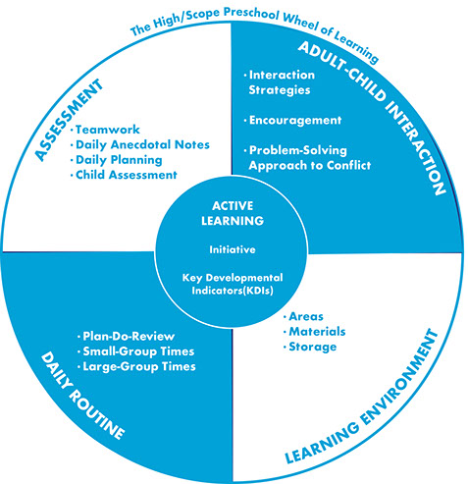

Classrooms ----------------------------------------------------------------------------------------------------------------

CLASSROOM | AGE RANGE
Tiny Learners 1 | 6 weeks-14 months
Tiny Learners 2 | 6 weeks-14 months
Voyagers 1 | 14 months-24 months
Voyagers 2 | 14 months-24 months
Explorers 1 | 30 months-36months
Explorers 2 | 24 months-30 months
Young Preschool 1 | 3 years-4 years
Early Preschool | 3 years-4 years
Pre-K+ | 4 years-kindergarten

Discipline ------------------------------------------------------------------------------------------------------------------

Greater Midland uses the High Scope 6 Step Conflict Resolution Strategy. When the conflict or behavior demands further action children may be offered time to “cool down” in a “safe spot.” Children may be temporarily excused from the classroom environment if the child or teacher is in need of further support. Teachers may bring a child to the administrative office when redirection has been ineffective and further support or intervention is necessary.
If a child’s behavior is harmful to themselves or others, inappropriate for the classroom setting or distracting to other children a teacher may temporarily excuse a child from the classroom and bring them to the administrative office.
If redirection is ineffective parents/guardians may be contacted. If behaviors persist a “behavior plan” should be developed with input from staff and parents/guardians. Greater Midland can help parents/guardians navigate the referral process for behavioral services if further support is required. When behavioral needs exceed our resources suspension or separation from care could occur. Greater Midland does not use traditional Time Out as a means of discipline. No form of corporal punishment, for
Discipline.
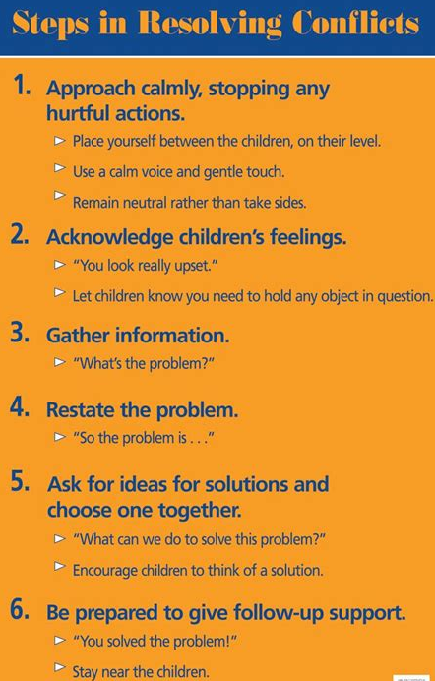

Special Needs Policy:--------------------------------------------------------------------------------------------------------

If a parent has concerns about their child’s development, they should begin by contacting the lead teacher. The lead teacher will discuss the parents’ concerns, age-appropriate development and discuss any data that might indicate a concern or need for additional supports in the classroom.

The teacher will also offer additional supports and strategies that the parent can use at home. If the teacher and or parent/guardian identifies any concerns, they will request a special education evaluation. The LEA will then initiate an evaluation and determine a child’s eligibility or ineligibility for special education services.

Culture Diversity & Classroom Celebrations: --------------------------------------------------------------------
Materials in the classroom are developmentally appropriate, clean, safe, foster learning and are designed to reflect the home and community cultures and special unique needs of children in the program.

Materials depict a wide range of non-stereotyped role models and cultures. Materials reflect children’s interests, parental hobbies, employment, and community traditions. Each child and family will be supported in their cultural values and norms of the home.

All staff will have training opportunities annually to further their knowledge of enhancing their daily communications and curriculum planning. Classroom celebrations and guidelines holidays, birthdays and end of the year celebrations are very special occasions, which many children and families enjoy. Teachers will plan activities that are appropriate and engaging for all. No one is ever excluded due to their beliefs or practices.

Biting -----------------------------------------------------------------------------------------------------------------------

Biting while undesirable is a normal part of development. Infants/Toddlers explore the world through their mouths and while teething may engage in biting. Young children do not have the verbal skills to fully express themselves nor do they have the ability to fully control their emotions (these emotions can be positive or negative ranging from overexcitement to anger.) Biting brings about a quick response. Biting will be handled on a case-by-case basis. Parents/guardians may be asked to co-develop plans or strategies to help mitigate this behavior. If the behavior persists (like any aggressive behavior) after reasonable interventions possible suspension or separation from care may occur.

Health Plans ---------------------------------------------------------------------------------------------------------------
Healthy children and child development go hand in hand! When children are healthy, they learn better. Children’s health is very important in our programs, and there are several health requirements we must have on file.

(1) Complete Physical Examination (Health Appraisal). Children must have a current year physical examination on file within 30 days of the child’s first day of attendance in order to continue in the program. Please ensure that your doctor performs a complete physical and documents the information on the physical exam form and must have a doctor’s signature. Additional medical forms may need to be completed by your child’s doctor. If a child has allergies, asthma, seizures, diabetes, and/or other conditions more information may be required.

(2) Up-To-Date Immunizations:
Children must have the series of immunizations that are recommended by the State of Michigan Health Department in order to attend the program. A copy of the child’s immunization record must be in the child’s file. Your child must be up to date on all required immunizations (4DPT, 1MMR, 3 Polio, 3 Hepatitis B, HIB series, PCV series and Varicella (chicken pox)). Failure to comply may result in the child's removal from the program. (3) Waiver In 2014, Michigan modified the administrative rules that changed how nonmedical waivers for immunizations will be processed for school and childcare programs. The new rule requires parents/guardians who want to claim a nonmedical waiver to receive education from a county health department about the benefits of vaccination and the risks of vaccine-preventable diseases before claiming the waiver. A nonmedical waiver is a parent’s/guardian’s written statement indicating the religious or philosophical (other) objections to a particular vaccination(s). Based on the new rule, parents/guardians will no longer be able to submit an uncertified immunization waiver form to the school or childcare center. Parents/guardians will need to:

- Contact their county health department to receive immunization waiver education and to obtain a certified State of Michigan Immunization Waiver Form with the name of the program the child will attending.
- Take the certified State of Michigan Immunization Waiver Form to their child’s school or childcare facility.
- Parents/guardians will need to submit to the school or childcare center the completed, certified, nonmedical immunization waiver form and/or complete immunization record every year.

Communicable Disease Information & Medication Procedure: ----------------------------------------------------

Michigan law requires that schools report the possible occurrence of any communicable disease to the local health department on a weekly basis. To assist your child’s school in reporting possible communicable diseases to MCHD and prevent possible outbreaks, please be specific when reporting your child’s absence.

Handwashing
Children
- Immediately before & after eating
- After using toilet or having diapers changed
- Before using the water table/Sensory Table
- After playing outside
- After handling pets or pet objects
- Whenever hands are visibly dirty

Providers
- Before handling food, prepping bottles, or feeding children
- After use of toilet, assisting child using toilet or changing diapers
- After meeting any bodily fluids (wet or soiled diapers, runny noses, spit, vomit, etc.)
- Whenever hands are visibly dirty or after cleaning up: bathroom, room, toys etc.
- After removing gloves for any purpose
- Before and after giving or applying medication or ointment
- After blowing nose, coughing, sneezing

Illness ----------------------------------------------------------------------------------------------------------------------
By law, Greater Midland cannot accept children who are sick into the program. It is our priority to ensure the health and safety of all children and staff members. If your child has one or more of the following symptoms, please keep your child home and/or seek medical attention:
- A temperature of 100.4 or higher
- In infectious, communicable disease or condition
(Such as pink eye, chicken pox, influenza etc.)
- Yellow or green discharge from the nose
- Severe or constant coughing
- Difficulty breathing/wheezing
- Diarrhea (2 times in the same day) or loose, runny stools
- Vomiting or upset stomach
- Acting ill (lethargic or in pain)
- Head lice
- Any type of unidentified rash/sores (will need a note from a physician before returning to program)
- If your child does not feel well enough to participate comfortably in the program’s activities
- Covid related symptoms as outlined/defined by the CDC and the local Health Department

Your child must be symptom free for a minimum of 24 hours without the aid of a fever reducer before they will be able to return to care. Should your child present with one or more of these symptoms while in attendance, the parent/guardian will be notified immediately. The parent/guardian will be required to make arrangements for the child to be picked up from the center within 1 hour.

Medication ----------------------------------------------------------------------------------------------------------------
- All medication (including over the counter and prescription) such as sunscreen, diaper cream, antibacterial ointment, cough drops, bug spray, dietary supplements, Tylenol or individual medical procedures such as insulin injections, breathing treatments/inhaler, nutrition through a feeding tube etc. will ONLY be administered with prior written permission from the parent/guardian. Should your child require specific medical care or medication, the following procedures must be followed:
- Medication must be the original container (prescription medication must be in its original container with label)
- Label must have child’s first and last name
- Medication permission form must be filled out and signed by parent/guardian (this form is good for 3 months)
- All medication must be stored in a designated area, out of the reach of children
- Medication will be administered according to the directions on the label
- A staff member will maintain a record of the time, date and dosage of all medication given or applied to each child. Staff administering medication will sign medication form with first and last name
Parents/guardians are responsible for providing all necessary items for administering medication such as liquid measuring syringes, measuring spoons, Epi-pens etc.
If your child requires staff to engage in a support process for a medical condition (such as nutrition through a feeding tube, seizures, injections such as Epi-pen or insulin shots) parent/guardian will be required to submit an Emergency Action Plan (EAP) signed by your child’s physician.

Staffing & Volunteers ----------------------------------------------------------------------------------------------------

All staff are fingerprinted prior to unsupervised interactions with children, which includes felony, misdemeanor, and sex offender clearances. All staff must have a negative tuberculosis test (TB) on file before beginning employment. Any volunteer who works with children 4 or more hours in 2 consecutive weeks must have a negative communicable tuberculosis test on file and a background check completed before volunteering. Volunteers are always supervised and NEVER left alone with children.

In accordance with State of Michigan licensing regulations a Program Director will be present for a minimum of 6 hours daily when the program is in operation. A minimum of 2 center employees, one of whom is a caregiver shall be present at all times at the center. The minimum staff to child ratio shall be:
Infants- 2 ½ 1:4
2 ½ - 3 years 1:8
3 years- 4 years 1:10
4 years- 5 years 1:12

Emergency Incidents & Accidents -------------------------------------------------------------------------------------

Fire – Tornado – Chemical Release
Children and staff will proceed according to Emergency Action Plans (EAP) posted throughout the building. Practice drills are conducted on a regular basis to ensure competency in implementation.

*Greater Midland Community Center lower level is a designated tornado shelter area

Power Outage – Building Emergency – Internal/External Threat
Should a power outage or other building emergency occur, parents/guardians will be notified as soon as possible. All children will remain in the building or on the Greater Midland Community Center campus until parent/guardian arrives or alternative arrangements are made.
Should a threat occur in or near our facility- staff will ensure all policies/procedures outlined in our EAP are followed. Practice drills are conducted to ensure competency in implementation.

Chemical Release and Other Situations
This is a lockdown situation. Children and staff will remain in the building. Parents may not pick up their child at this time. A parent/emergency contact will be notified when the authorities have announced that it is safe to leave the building.
Fire drill
- Gather the children at the exit door and leave quickly.
- Take attendance roaster and emergency bag.
- Taka attendance as soon as your group arrives at the designated meeting area.
- Record time of the drill on the roaster, make two copies file one in the classroom accordion file and submit one to the childcare office.
(In the event of a fire parents/emergency contacts will be called and staff will remain with the children until all children are picked up).
Tornado Drill
- Done during tornado season
- Know the exit from your classroom
- Take the attendance roaster and emergency bag.
- Proceed to the shelter on the bottom floor of Greater Midland Community Center
- Be prepared to interact and keep children engaged
- Record time of the tornado drill on the roaster, make two copies, file one in the classroom accordion file and submit the other to the childcare office.
(In the event of a tornado- this is a lockdown situation. Parents may not pick up their child at this time. A parent/emergency contact will be notified when authorities have announced that it is safe to leave the building).
Gunfire Drill
Shots on the playground/walk:
- Communicate to children to “Drop, laydown”
- Look to make sure the children are all down.
- If a child does not drop the nearest adult calls the child’s name, crawls to him/her and pulls them down.
- Contact 911 by cell phone if possible.
- Wait approximately 5 minutes after shooting stops. Teachers stand first.

Gunshots When in Classroom:
- Communicate to children to “Drop, laydown”.
- Children should be directed to quickly crawl and run to a designated safe space away from the line of sight.
- Classroom doors should not be open for anyone for any reason- When the threat is over authorities will unlock doors and evacuate children and staff.
(In the event of gunshots in classroom- this is a lockdown situation, parents may not pick up their child at this time, parents/emergency contacts will be notified when authorities announce that it is safe to dismiss the children to the care of parents/emergency contacts).

Serious Accident/Injury/Incident -------------------------------------------------------------------------------------------------

In case of serious accident/injury or when the extent of the injury is unknown, we will follow the procedures as outlined below:
- Staff will assess the situation and call additional staff/supervisor for additional assistance if necessary
- 911 will be called if the emergency is life threatening. If the child requires transportation for medical services a staff person will accompany the child and remain with the child until the parent/guardian arrives.
- If the injury is not life threatening but requires medical attention, a member of the Greater Midland Early Care & Education team will contact the parent/guardian to notify them of the accident/injury. Transportation for medical attention will be decided by the parent/guardian.
- An accident/incident report will be completed by staff members who witnessed the injury and submitted to the Greater Midland Central Office.
- An “Ouch Report” will be provided for minor injuries.
- A verbal report of the accident/injury (if medical attention is required) will be made to the Department of Health & Human Services within 24 hours of the incident. An “Incident Report” (BCAL 4605) will be submitted to DHHS within 72 hours of the incident.
- Parents will be notified immediately by phone and or text message when a child is injured/ serious accident or is missing and or lost from care. An “Incident Report” (BCAL 4605) and a verbal report of missing child will be made to the DHHS as well as submitted to DHHS within 72 hours of the incident.

Reporting Abuse & Neglect ---------------------------------------------------------------------------------------------

Under the Michigan Child Protection Act 238. As mandated reporters all Greater Midland Early Care & Education employees are required by law to report any suspected child abuse, neglect, sexual abuse, or exploitation to Children’s Protective Services. Greater Midland does not have to warn or inform families of making a report, we will not disclose information about our report to any unauthorized person or to family members. Our highest priority is the safety and wellbeing of the children we serve.

Withdrawing From the Program---------------------------------------------------------------------------------------

Parents/Guardians are responsible for giving a 2-week advanced notice of withdrawal. Families who have not turned in a calendar for care for one month will automatically be withdrawn from care and will be required to follow the enrollment procedure if space is available to re-enter the program.

Dismissal -------------------------------------------------------------------------------------------------------------------

Greater Midland reserves the right to discontinue service at any time, with or without cause. Past due balances must be paid within 30 days of dismissal. An invoice detailing the past due balance will be forwarded to the address indicated on the child’s file within 10 days of the dismissal. Any balances remaining after the 30-day period will be referred to the program’s collection agency.

Grievance Policy ----------------------------------------------------------------------------------------------------------

Greater Midland believes that children always benefit from strong relationships between our team and parents/guardians. The relationship between our program and home should be one based on mutual respect and appreciation for our interdependency on each other. We recognize that, as in any relationship, occasional good faith disagreements may arise.
If you have any concerns about an aspect of the program, please adhere to the following steps:
If applicable, the parent/guardian shall discuss the issue with the Lead Teacher. If no resolution is reached, then the parent/guardian shall discuss issue with the Program Director.
If parents/guardians feel the decision regarding the matter is unsatisfactory they may present, the concern to the Director of Early Care & Education.

Thank You

We value the trust and confidence you place in the Greater Midland team to provide your child with a high-quality Early Care & Education experience. Thank you for allowing your kids to be “our kids.

